SOP – Azure VM Image Replication: Add Sweden Central (Latest Versions Only)
Version 1.0 · October 2026

Purpose
Our VM images sit in an Azure Compute Gallery in North Europe and are replicated to North Europe only. This SOP adds Sweden Central as a replication target for the latest image versions only, so we can deploy there without paying to copy the whole version history.

Why
- A VM can only be built from an image version that has a replica in that region.
- A second EU copy gives us a fallback if North Europe has problems.
- Every replica is billed as storage, per region. New builds always use the latest version, so copying old versions is wasted spend.
- Scope: latest 2 versions (current + previous for rollback). Everything older stays in North Europe.

Before you start
- Contributor access on the gallery's resource group
- Approved change ticket
- Latest 2 versions identified (Versions tab, sorted by Published date)
- Sweden Central allowed by Azure Policy on the subscription
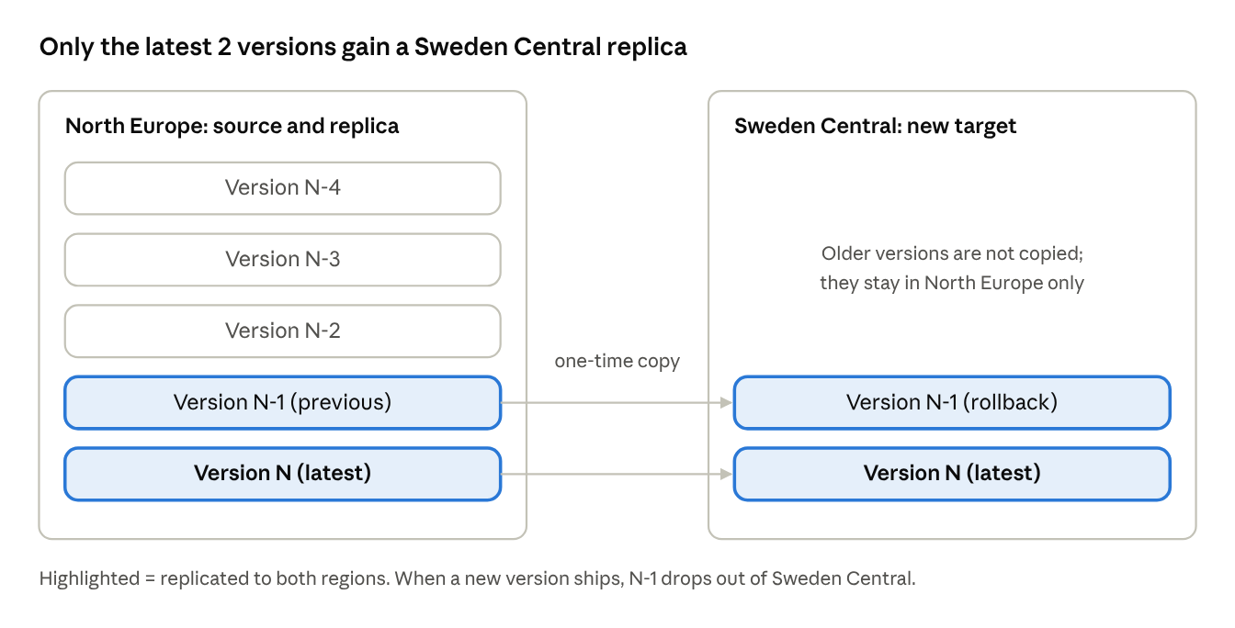
replication scope · current vs target

Steps (Azure portal)
- In the portal, search Azure compute galleries and open the gallery.
- Open the image definition and go to Versions. Sort by Published date and note the latest two. Their replication should show North Europe only.
- Open the latest version and select Update replication (under Settings).
- Under Target regions, add Sweden Central:
  - Replica count: 1 (increase only for large parallel deployments, roughly 1 per 20 VMs)
  - Storage SKU: Standard LRS (Standard ZRS if we need zone resilience)
- Leave the North Europe row exactly as it is. Removing it deletes that replica.
- Click Save.
- Repeat steps 3–6 for the previous version. Do not touch older versions.
- On the version's Overview, check Replication status. Wait until Sweden Central shows Completed.

Validation
- Latest 2 versions list North Europe + Sweden Central; older versions list North Europe only.
- From the latest version, click Create VM, pick Sweden Central, confirm it deploys and boots, then delete the test VM.

Rollback
Open the version → Update replication → remove the Sweden Central row → Save. North Europe is not affected.

On every new release
- When creating the new version, add both North Europe and Sweden Central on the Replication tab.
- Remove Sweden Central from the version that is now third-latest (Update replication → remove row → Save). This keeps Sweden Central at exactly 2 versions.

Cost impact
Adding Sweden Central for the latest 2 versions costs about $7.68/month (~$92/year) per image for a 64 GB image. North Europe cost doesn't change; the gallery itself is free.
What we pay for
- Replica storage in Sweden Central: ~$0.05 per GB per month (Standard LRS snapshot rate), per version, per replica
- Copy from North Europe to Sweden Central: $0.02 per GB, once per version
- Extra replicas inside Sweden Central: no transfer charge, storage only
Formula
Monthly increase = (versions kept × replicas × image size GB × $0.05) + (new versions per month × image size GB × $0.02)
Example – 64 GB image, latest 2 versions, 1 replica, 1 release per month
Item | Calculation | Cost
Storage | 2 × 1 × 64 GB × $0.05 | $6.40 / month
Copy of new release | 64 GB × $0.02 | $1.28 / month
Monthly increase | $6.40 + $1.28 | $7.68
Yearly increase | $7.68 × 12 | $92.16
One-time initial copy | 2 × 64 GB × $0.02 | $2.56
Options compared (64 GB image)
Option | Monthly | Yearly
Latest 1 version | $4.48 | $53.76
Latest 2 versions (chosen) | $7.68 | $92.16
All versions (e.g. 12) | $39.68 | $476.16
Limiting it to the latest 2 saves ~$32/month per image versus replicating everything. Figures are pay-as-you-go list prices in USD; check the Azure Pricing Calculator for our actual rates and multiply by the number of image definitions in scope. VM costs in Sweden Central are not included.

